Create SSIS Package for loading multiple flat file(10 or 20) and load into SQL table.  
Use For Each container.

Source files:

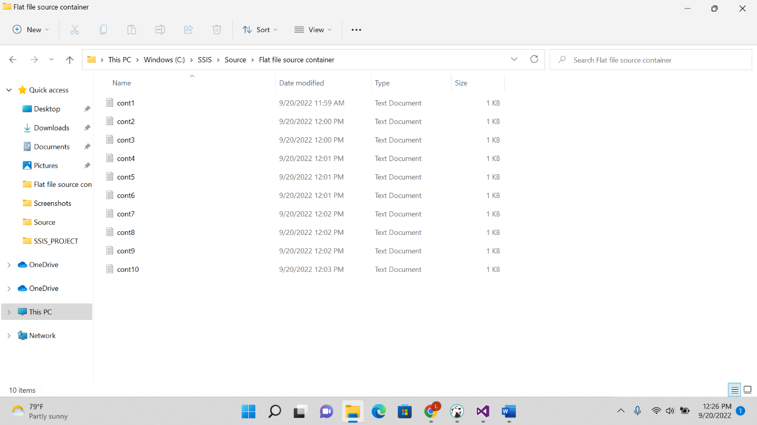

Package execution:

